**Java Orientation Session (09-05-2023)**

NCS-Shripad Patil

Telecommunications domain

singtel BU

3-4 people assigned to each lead

9-9:30, 5-5:30 - meetings with leads

Telecom Centric Projects

Stackbook,gitlab

assignments

refactor -> learn

capstone project->Banking/Telecom project

mentor - Annu Sharma

.net - sharad

testing - durai

SAP- Piyush Bagri

Ayesha Khan, Prathima(POC), Elyas - service delivery manager - StackRoute

Tineshwari - operations - stackroute

**10-05-2023 (Angular)**

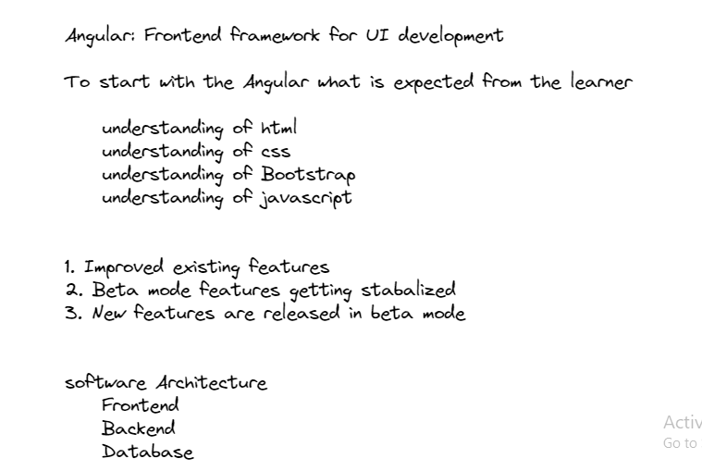

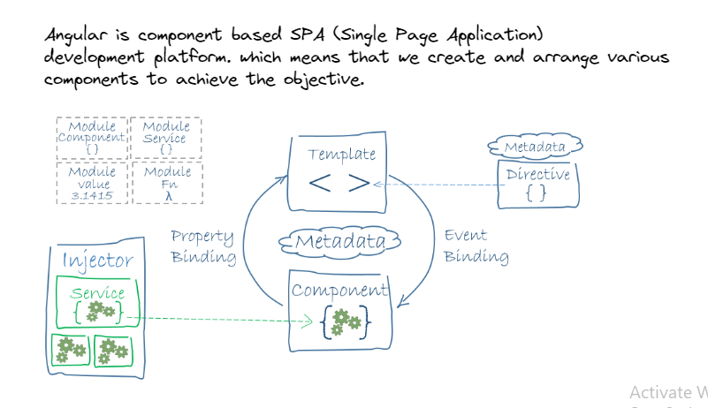

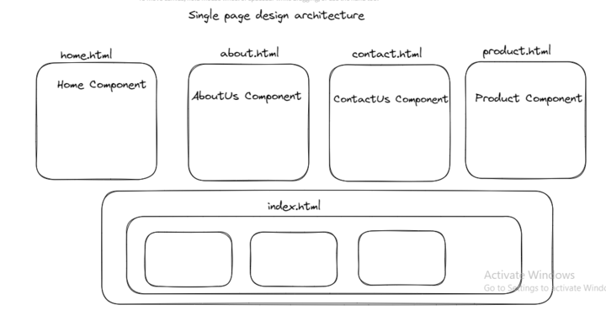

To run application on different port no:

ng serve --port ‘port-number’ -o

**11-05-2023 (Angular)**

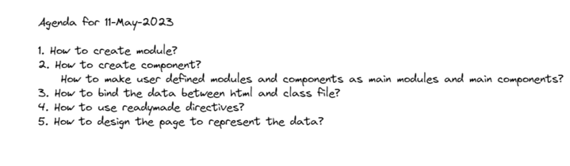

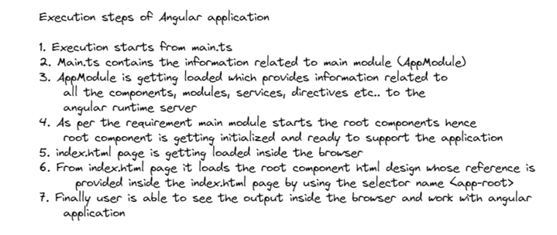

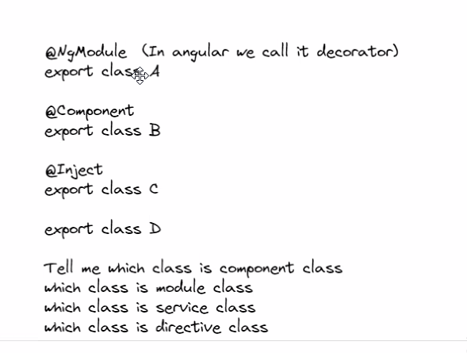

**12-05-2023 (Angular)**

[**https://angular.io/guide/lifecycle-hooks**](https://angular.io/guide/lifecycle-hooks)

3 assignments would be given (from Monday onwards)

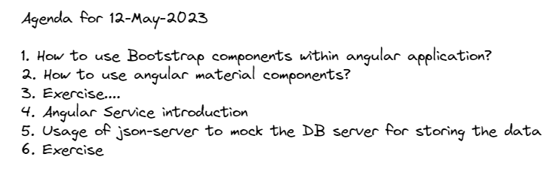

**15-05-2023 (Angular)**

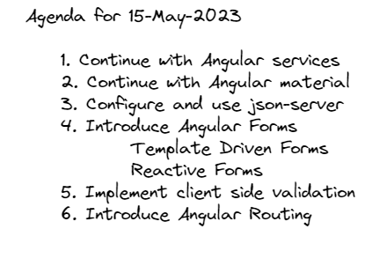

Different types of forms in angular:

**Template Driven form**

1. It is implemented by using simple HTML, CSS, Bootstrap and Material components
2. It requires forms module to be imported inside the main module.
3. Validation of data is done using required directives provided by angular.
4. ngForm and ngModel is required to manipulate forms data
5. used to achieve simple objective like login, register, forgot password etc.

**Reactive Form**

1. It is implemented by using simple HTML, CSS, Bootstrap and Material components but controlled by typescript code.
2. It requires reactive forms module to be imported inside the main module.
3. Validation of data is done using validators class and various other validation classes provided by angular.
4. FormGroup, FormControl, FormBuilder etc are used to control forms related activites and manage data.
5. It is mainly used in the situation where we are mainly dealing with complex and dynamic data.

<https://angular.io/guide/forms-overview>

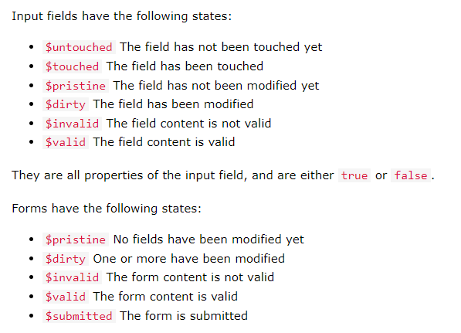

Validations, references

**16-05-2023 (Angular)**

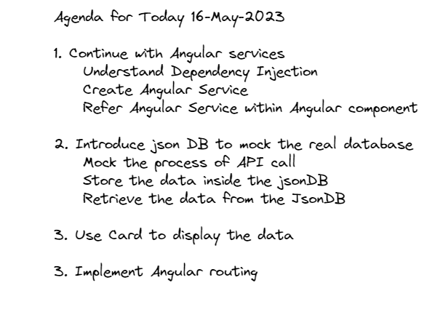

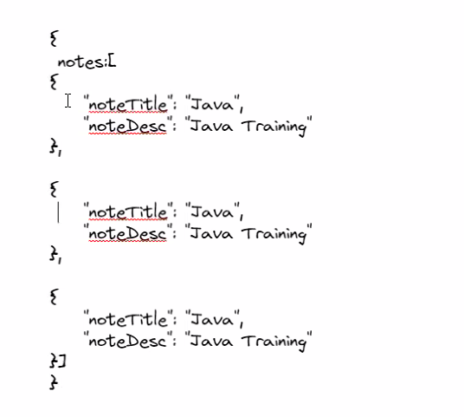

<https://angular.io/guide/observables-in-angular>

<https://angular.io/guide/architecture-services>

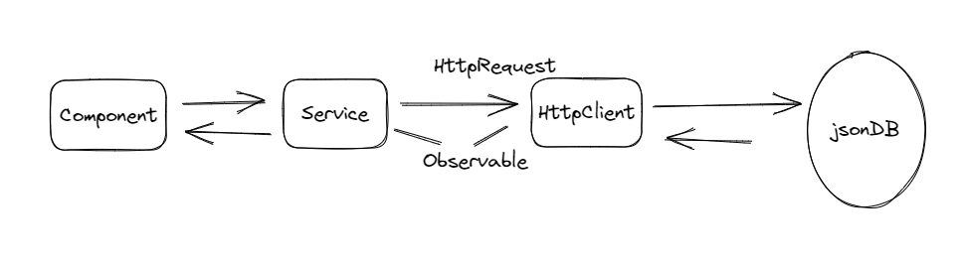

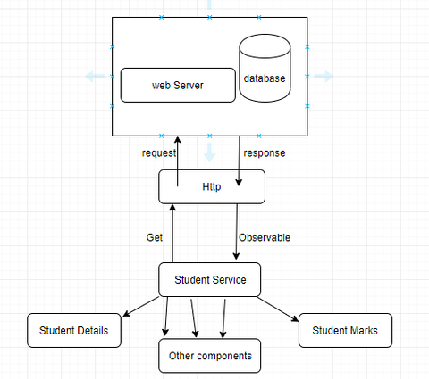

**1. Create register component**

**2. Allow user to register and data will be stored inside the jsonDB**

**3. Admin should be able to see all the users registered**

**4. Allow the user to login, validate the user based userid and password**

**provided while registration**

**5. Implement routing so that user can navigate to respective component page**

**as and when required**

[**https://gitlab.stackroute.in/stack_angularv7_keep/angular7-keep-level-1-assignment.git**](https://gitlab.stackroute.in/stack_angularv7_keep/angular7-keep-level-1-assignment.git)

**17-05-2023 (Angular)**

Assignment, angular guards

**18-05-2023 (Angular)**

API: why api is used?, what was used before api was there? How was data stored before rdbms?

Web services

URI and URL

Insomnia, postman (api testing tools)

Removed // "es5BrowserSupport": true from angular json from assignment

Created two services in keepapp to authenticate user based on token generated

Ng g s auth

Ng g a router

Token is being generated by the server

Npm run test -> to run tests

<https://rxjs.dev/guide/operators>

<https://insomnia.rest/download>

**19-05-2023 (Angular)**

Unit testing

Assignment-2 assigned

Software testing and TDD are different things

.spec.ts is testing file

What is expected in software is written in SRS

Jasmine testing

<https://jasmine.github.io/>

<https://jasmine.github.io/api/edge/matchers.html>

**22-05-2023 (Angular)**

[**https://www.cypress.io/**](https://www.cypress.io/)

[**https://docs.cypress.io/guides/overview/why-cypress**](https://docs.cypress.io/guides/overview/why-cypress)

[**https://medium.com/@daniel.glejzner/angular-16-is-out-now-learn-how-to-replace-rxjs-with-signals-c1f6f410809**](https://medium.com/@daniel.glejzner/angular-16-is-out-now-learn-how-to-replace-rxjs-with-signals-c1f6f410809)

Cypress Library is required for testing after ng7.

Before ng7, protractor was used for testing.

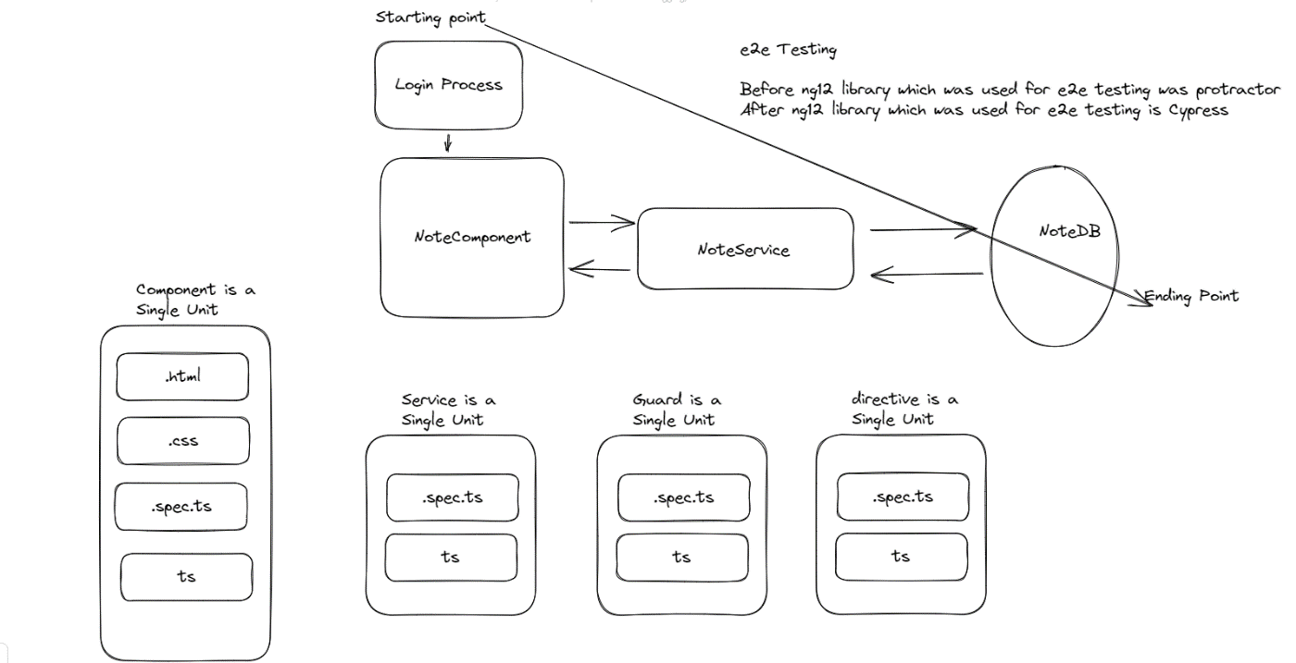

Add cypress library

npx cypress open

**23-05-2023 (Angular)**

Nesting of components

Implementation(vscode): distributing the code into various components

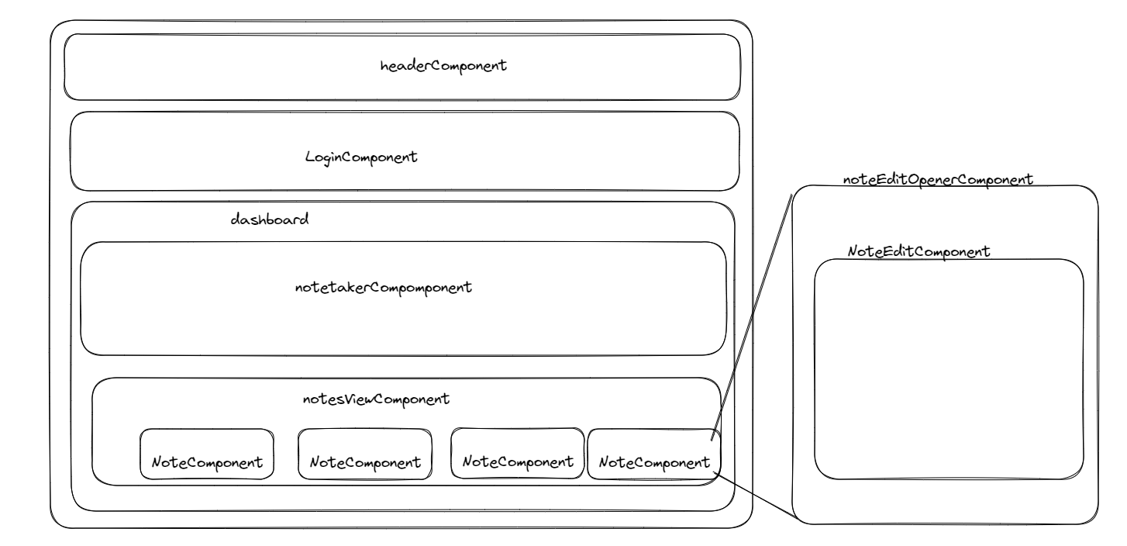

<https://rxjs.dev/api/operators/tap>

**24-05-2023 (Angular)**

Worked on assignment whole day

**Links and Commands**

Set-ExecutionPolicy -Scope CurrentUser -ExecutionPolicy RemoteSigned

<https://angular.io/cli/serve>

<https://angular.io/guide/file-structure>

<https://www.typescriptlang.org/docs/>

**25-05-2023 (Java)**

Advance Java Concepts:

Collections, Generics

Overview of Threading, Multithreading

Hibernate ORM

New Java Features

Interface Enhancements; Functional Interfaces; Lambda expression

ForEach – Iterable; Method References

Stream API, Filters, Date Time

Java Testing and code coverage:

Unit Testing with Junit

Testing with Mockito;

Code coverage with JaCoCo;

Configuring Inputs with properties/ResourceBundle;

**Purpose of DS in programming-**

to handle the data efficiently

to store the data

to manipulate the data

to arrange the data

to retrieve the data